Cleantech Challenge 2022

Background
Many states in the US are announcing ambitious targets to become 100% clean. But what does that mean? It means that the consumption will have to match the clean electricity generation for every hour on every grid– that is every MW of electricity consumed can be accounted for by either a MW of clean energy produced or an equivalent measure of carbon captured from the atmosphere. The end state will be a fully decarbonized electricity system. Many are still considering clean energy solely as renewable energy, but it is fair to say that going forward the term clean energy will broadly consist of carbon free energy (renewable, hydro, storage, nuclear, carbon capture, etc.).
Today many consumers claim to be carbon neutral, but this is a deceptive claim as it is only true on an annual aggregate basis. In other words, they are not clean every hour, but rather produce more renewables in some hours than they consume carbon intensive energy in other hours.. Fortunately, the new trend is now 24/7 Carbon Free Energy (CFE). Annual aggregates will no longer meet progressive energy standards, and instead, energy must be clean in every hour for an entity to be considered carbon free. It means clean energy for every hour everywhere. This is an essential path toward a 100% clean power world.
The path toward 24/7 Carbon Free Energy is not easy. Many challenges exist including the transparency of the data, the carbon free technologies available at an affordable price, the marketplace to gather buyers and sellers of CFE products (as vendors of residential battery systems, solar vendors etc.). Google leads this trend for Commercial and Industrial (C&I) customers and announced their ambition to operate entirely on 24/7 CFE at all of their data centers and campuses worldwide by 2030.
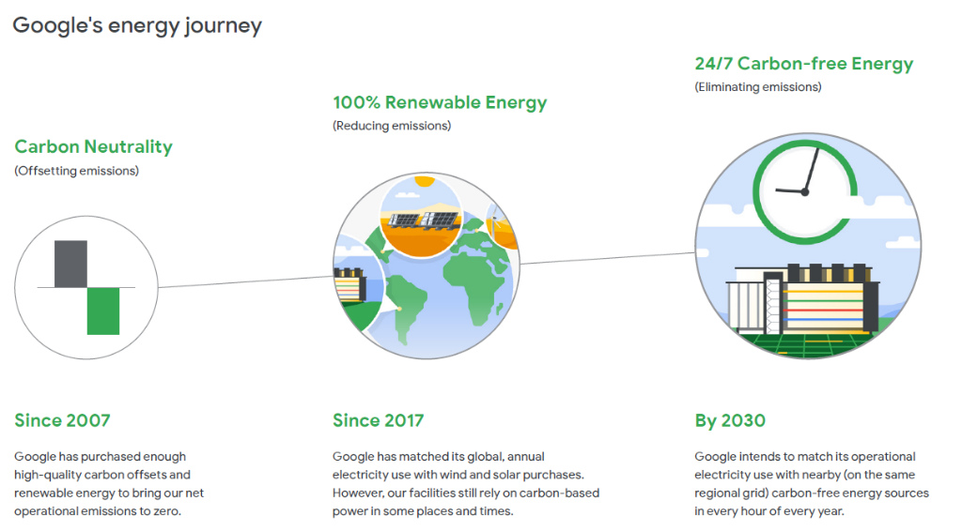

Multiple challenges have been brewing on the residential side particularly with changes in Net Metering rules. When regulators tried to modify the net-metering rules, they faced backlash from both sides of the aisle. The best example is in California where NEM 3.0 (Net Energy Metering) is now in place. Utilities claimed that the net metering reduces their revenue and renders the grid unreliable while customers, Developers and Clean Energy advocates claim that the rebates and compensation are not enough.

Challenge statement
It is now obvious that CFE generation must match with the consumption every hour of every day. But how can we accelerate the transition from early adopters like Google to other customers both at commercial/industrial and residential scale. An ecosystem to promote this 24/7 CFE trend has to grow. With such a community advocating for 24/7 CFE, technology developer and regulator will find the best solutions to help the decarbonization of the grid.
Your challenge would be to find how to promote the 24/7 CFE both for C&I consumers and residential consumers. You will have to find the right arguments and strategies based on economic and regulatory analysis.

Mission Statement
Your objective is to propose action plans to help C&I and residential customers achieve 24/7 CFE before the state and federal RPS deadlines (100% clean energy in California by 2045 and goal of net-zero across Federal operations by 2050). The action plans have to be linked with arguments showing the benefits for the customer and the grid.
Interesting approaches to examine include (but are certainly not limited to):

For Residential customers
- A 5-minute presentation that identifies implementation barriers and associated costs in existing legislation and advocates for updates (Focus at state level can be on states which are implementing laws that are not favorable for distributed generation, like Florida or California or the focus should be at the federal level).
- A basic economic analysis on how the recommended legislative plan is beneficial for customers.
- An action plan which details the effects on the utilities, grid or other stakeholders and throw light on resistance this plan could face and make a strong case for its implementation.

For C&I customers
- A 5-minute presentation aiming at promoting 24/7 CFE with precise arguments of the value for the system.
- An economic analysis of the cost to reach x% CFE (x from 0 to 100) based on the accessible technologies and expected cost in the coming years. x% CFE is the CFE Score which measures the degree to which each hour of the electricity consumed is match with CFE on an hourly basis. For example, a consumer who is located in a grid with a CFE Score of 30% will reach 30% CFE at the wholesale electricity price. If he wants to reach a Score closer to 100%, he will have to buy expensive technologies so his cost will include a premium to the wholesale electricity price.
- A recommendation paper for the public agencies or government department such as FERC, CEC or DOE for new regulation concerning the REC (Renewable Energy Certificate) markets with the identification on the implementation barriers and possible solutions.
Deliverable
- For each customer segment (residential and C&I), provide:
  - 5-minute presentations with accompanying slide decks. The presentation should mention to whom it is addressed (e.g., FERC, CEC) and what is the purpose (e.g., proposed legislative update, recommended action plan).
  - Slide deck should include slides presenting an economic analysis of the costs or benefits.
  - The presentation should include details explaining the choice of these recommendations and why they are important to promote 24/7 CFE.

Evaluation checklist:
- Original approach for the action plan that differs entirely or in part from what is currently discussed by energy buyers, energy suppliers, governments, system operators and solutions providers
- Effectiveness of the solution to promote efficiently 24/7 CFE consumption
- Appropriate choice for the presentation
- Quantitative data provided when necessary on the economic analysis
- Clarity of the argumentation, both written and oral
Contact:
If you have questions throughout the event, please feel free to reach out to Olivier Deneux (olivier.deneux@edf-inc.com) and Roma Notani (roma.notani@edf-inc.com).

Vocabulary:
Clean Energy: Clean Energy is energy that is produced through methods that do not release greenhouse gases or any other pollutants. Among clean energy sources, there are renewable energy, nuclear energy, hydrogen produced with decarbonized electricity and others.
DER: Distributed energy resources are small-scale units of power generation that operates locally and is connected to a larger power grid at the distribution level.
C&I customers: Commercial and Industrial consumers include any commercial or industrial retail customer (non-residential).
RPS: Renewable Portfolio Standards are policies designed to increase the use of renewable energy.
REC: Renewable Energy Certificate are market-based instrument that certifies the bearer owns one megawatt-hour of electricity generated from a renewable energy resource.
CEC: the California Energy Commission is the state’s primary energy policy and planning agency.
FERC: the Federal Energy Regulatory Commission is an independent agency that regulates the interstate transmission of electricity, natural gas, and oil.
DOE: the Department of Energy manages the United States' nuclear infrastructure and administers the country's energy policy. The Department of Energy also funds scientific research in the field.
Net-Metering: Net metering allows residential and commercial customers who generate their own electricity from solar power to sell the electricity they aren't using back into the grid.
24/7 CFE: 24/7 Carbon-free Energy (CFE) means that every kilowatt-hour of electricity consumption is met with carbon-free electricity sources, every hour of every day, everywhere. It is both the end state of a fully decarbonized electricity system, and a transformative approach to energy procurement, supply, and policy design that is critical to accelerating its arrival.

References:
These references are meant to help you get a better understanding of the problem at stake and the different approaches utilities and the energy industry have been focusing on. Each reference includes a short description to help you assess which one you want to focus on (you do not need to read all the references).
24/7 Carbon-free Energy Compact – A group of energy buyers, energy suppliers, governments, system operators, solutions providers and investors joining their effort to accelerate the decarbonization of electricity grids.
https://www.un.org/en/energy-compacts/page/compact-247-carbon-free-energy
Operating on 24/7 Carbon-Free Energy by 2030 by Google – Commitment’s form, objectives, white papers to explain the methodology…
https://sustainability.google/progress/energy/
Energy Tag – A non-profit initiative aiming at defining 24/7 CFE and building a market for granular certificates of energy.
https://www.energytag.org/publications/
The battle over net metering 3.0 in California – articles by Canary Media explaining the debate around the new rule of NEM 3.0
https://www.canarymedia.com/articles/solar/californias-net-metering-3-0-battle-energy-equity-and-the-future-of-rooftop-solar
https://www.canarymedia.com/articles/policy-regulation/california-net-metering-proposal-would-decimate-rooftop-solar-market-industry-says
Cost of Electricity Generation – Current cost by technologies given by the International Energy Agency
https://www.iea.org/reports/projected-costs-of-generating-electricity-2020
https://www.iea.org/articles/levelised-cost-of-electricity-calculator

About EDF and the EDF Innovation Lab:
About EDF group
EDF Group ($84 billion in revenues in 2021, about 170 000 employees) is a French energy corporation that operates a diverse portfolio of 120+ gigawatts of generation capacity around the globe. EDF covers every sector of expertise, from generation to trading and transmission.
Research priorities for the group include: (1) Electricity transition: Energy storage for mobility and stationary usage, electrification as a means of reducing CO₂ emissions, smart and sustainable cities and territories, smart-grid and microgrid, (2) Climate transition: An optimized electricity grid combining nuclear and competitive renewables energy, (3) Digital and social transition: AI, digital revolution at the service of our engineering and processes, the dynamic of social evolution.
Overview of the EDF Innovation lab (Los Altos, CA)
The mission of the lab as part of the R&D is twofold. On the research side, the aim is to explore, research and test breakthrough technologies to support the growth of the EDF group in decentralized, data-driven and low-carbon energy sectors. On the development side, our goal is to explore new markets, (co) develop new products and launch new services for EDF Group in North America, leveraging the innovation of the Bay Area and building local partnerships.
Examples of projects we have been working on include work on understanding how to achieve 100% clean power generation and the market design implications this shift would require, the trading of green certificates on the blockchain, doing some transmission & distribution congestion prediction using data sciences, analyzing the value of storage and DER for the state of New York and innovative projects on micro-mobility enabling technologies among many other.

https://environmentamerica.org/feature/ame/100-renewable ² https://www.gstatic.com/gumdrop/sustainability/24-7-explainer.pdf
³ https://www.gstatic.com/gumdrop/sustainability/carbon-free-by-2030.pdf
https://www.cpuc.ca.gov/industries-and-topics/electrical-energy/demand-side-management/net-energy-metering/nem-revisit/net-billing-tariff-fact-sheet
https://www.gstatic.com/gumdrop/sustainability/24x7-carbon-free-energy-methodologies-metrics.pdf

